**Student Name:** **Weight: 85**

**Student ID:** **Marks: __________**

**CREATE AN EMPTY DOCUMENT TO SUBMIT YOUR SOLUTIONS. DO NOT USE THIS DOCUMENT TO SUBMIT YOUR ANSWERS. YOU WILL LOSE 10% FOR DOING SO!!!**

Assignment 1:

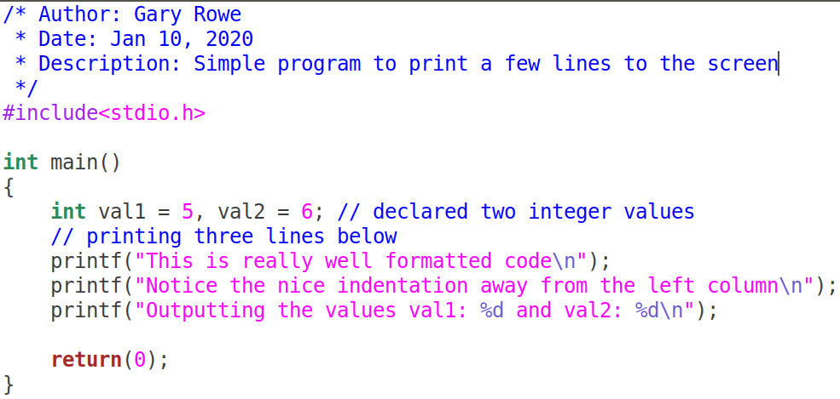Your C files should be properly ***formatted*** with ***indentations*** that enhance code ***readability***. Example of properly formatted code:

**Important:**

**CREATE AN EMPTY DOCUMENT TO SUBMIT YOUR SOLUTIONS. DO NOT USE THIS DOCUMENT TO SUBMIT YOUR ANSWERS. YOU WILL LOSE 10% FOR DOING SO!!!**

* On your Ubuntu VM guest machine create a folder called ITSC202.
* Inside the ITSC202 folder create a subfolder called **A1**.

A1 is the folder you will use for all the C files for **Assignment 1**.

* **All Assignments must have an image showing the execution of the program.**

Problem 1 (15):

You have been asked by a math teacher to write a program for her students to calculate the sum and average of 10 numbers. The numbers can be either floating points or integer numbers.

The criteria are as follows:

* Create a file called **prob1.c**
* **The program will ask for 5 numbers of type integer**.
  + Your program will print the **sum**, **average** of those values entered.
* **The program will ask for 5 numbers of float type.**
  + Your program will print the **sum**, **average** of those values entered.
* The floating-point values will show only 2 decimal places in the output. See the image below.

The image below shows an example execution of the program:

**You will submit the C source code and 1 sample run of your program**

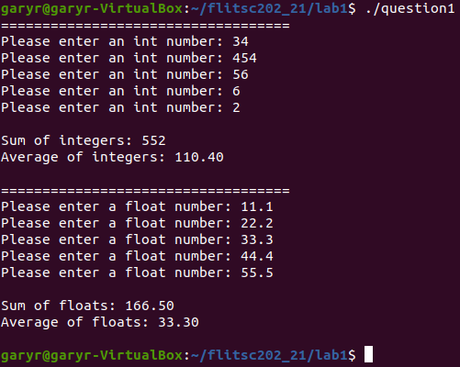

**IMPORTANT: Notice that the result of calculate the average is always a floating pointer number.**

Problem 2 (15):

You have been asked to write a program that prints a message based on a number entered by the user. Each number will be associated to a name. Your menu can include different names or topics of interest to you.

The criteria are as follows:

* In the folder assignment 1, create a file called **prob2.c**
* The program should print 5 – 10 words or phrases on the screen with a unique **capitalized letter** associated to those words. The letters do not need to be sequential but they must be unique.
* The user will be asked to enter a letter associated to the menu words
* In response the program will echo, the letter the user entered.

The image below shows an example execution of the program:

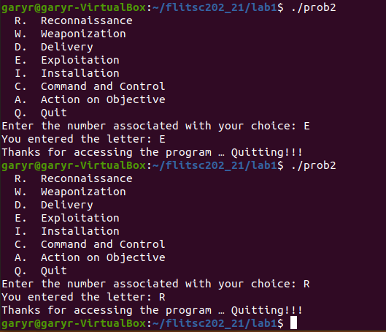**You will submit the C source code and 1 sample run of your code.**

**NOTE: We have not had a lesson on how to match user input to a word. If you know how to do so, you can modify the program so that it prints the word associated with the user input.**

Problem 3 (15):

Write a program that prints the pattern shown below:

The criteria are as follows:

* In the folder Assignment 1, create a file called prob3.c.
* Use only 3 printf statements to complete this question.

Question (**3pt**)

1. Can the problem be completed using only 1 printf statement?
2. Show the single C printf statement that you would use to accomplish the task.

**You will submit ONLY the C source code and an image showing the output**

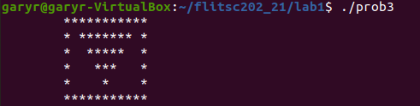

Problem 4 (15):

Copy the following C code, compile and execute it; then do the following:

1. Analyze the program to ensure you understand what is happening
2. Comment the code with meaningful statement where needed.
3. **Submit your commented code and answers to the questions below**
4. Answer the following questions:
   1. At **lines 5, 6 and 7**, what are the values of each variable (**aval, bval and cval**)?
   2. At line 7, how did cval get its value?
   3. What does the qualifier **unsigned** do?
   4. What does the qualifier **short** do?
   5. At lines 11 and 12, 1 is added to aval. **Why does aval remain unchanged?**
   6. After the operations on lines 11 and 12, why are the values of bval and cval different?
      1. **HINT: Think about how much data each data type can hold.**

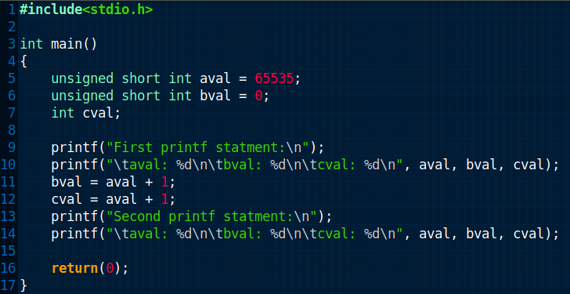

**Investigate other keywords like long, const and static. Ask yourself, how can I use these keywords.**

Problem 5 (25):

Analyze the following lines of code. Fix the code so that it will run. You will likely need to

* Rename variables
* Determine if syntax is correct
* Ask Google how casting in C works

In **point format** explain the steps you had to take to fix the code. Example:

1. Changed variable name to match …
2. Terminated statements at line …

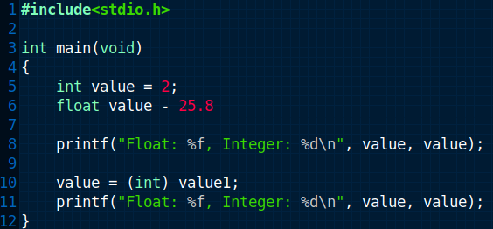

Answer the following questions, **after fixing the code**:

1. What operation is line 10 attempting to accomplish?
2. Why is the output of lines 8 and 11 different?